**Delivery Specifications for Project FlyAway**

Specifications Documentation

**Date: 23-03-2022**

**Version: 1.0**

Table of Contents

Delivery Specifications for Product Digitization Project FlyAway 3

Project and Developer Details 3

Sprints Planned and Tasks Achieved 3

Core Concepts Used in the Project 3

The Product Capabilities: 3

The Product Appearance & Interactions: 4

LockedMe Application Workflow Details 4

Tools & Platform Used 4

Steps and Algorithms 5

Screenshots 7

Conclusion 10

Unique Selling Points 10

# Delivery Specifications for Product Digitization Project FlyAway

## Project and Developer Details

Company Lockers Pvt. Ltd. has requested me as a Full Stack Developer to develop a prototype application. The goal is to create As a Full Stack Developer, design and develop an airline booking portal named as FlyAway. Use the GitHub repository to manage the project artifacts. This will be a Scrum Product that will have one version of code release for this product. The company’s goal is to deliver a high-end quality product in the next 15 working days (3 weeks). The product will be a prototype application and will be presented to the relevant stakeholders for the budget approval.

As a Full Stack Developer, I will complete the development and features of the application by planning and submitting development sprint documentation and code, using school specified sharing Google Docs to store product documents and the GitHub repository to store and push the source code. Since this is a prototyped application, the user interaction will be accessed through a console application using command line code.

## Sprints Planned and Tasks Achieved

1. This project will use the Agile Scrum Methodology. The development code will have one version of code for release, in a three week sprint timeframe. The code deliverables will be delivered using a GitHub Application, in a Code Repository called LockedMe.
2. The Technical Documentation will be a Visio flow chart that will show the flow and algorithms being used in the application.
   1. Code will be worked on daily and pushed into repository when code is finished.
      1. Link for Git Hub Repository:
         1. <https://github.com/SMuse3/FlyAway>
   2. Developer will make a text document of application steps and algorithms
   3. Developer will make a flow chart to diagram the flow of the application
3. The Specification Document will be a word document, this document, which will list the core concepts; product capabilities, product appearance, product user interactions and the algorithms being used in the application along with other technical items used to develop project.
   * 1. Link for Open Source Google Docs:
        1. <https://drive.google.com/drive/folders/1k8E00lAtZsjBWfOBzUCsomzcYp7maItX?usp=sharing>

# Core Concepts Used in the Project

## The Product Capabilities:

The Product will be able to perform the following capabilities:

1. FlyAway Application Objectives:
   * To develop a system to management of airlines, this will perform all the functions with a click of mouse button’s
   * To develop a system that has good management of data along with integrity and minimizing redundancy.
   * To develop a system that will be user friendly in all possible ways.
   * To provide better customer support for passengers
2. The Product will be able to perform the following capabilities
   * **Book Flights** -  
     The user enters flight details (date, origin, destination, passengers). A query is sent to the remote database to fetch related flights and displayed to user. The User enters other details and proceeds to book the flight.  
       
     **Admin** -  
     Admin dashboard is accessed with a preset username and password. Admin can see all entries in database table. Admin can change his password after Login.

## The Product Appearance & Interactions:

* + A search form in the homepage to allow entry of travel details, like the date of travel, source, destination, and the number of persons.
  + Based on the travel details entered, it will show the available flights with their ticket prices.
  + Once a person selects a flight to book, they will be taken to a register page where they must fill in their personal details. In the next page, they are shown the flight details of the flight that they are booking, and the payment is done via a dummy payment gateway. On completion of the payment, they are shown a confirmation page with the details of the booking.
  + For the above features to work, there will be an admin backend with the following features:
  + Admin login page where the admin can change the password after login, if he wishes ● A master list of places for source and destination
    1. A master list of airlines
    2. A list of flights where each flight has a source, destination, airline, and ticket price
  + The goal of the company is to deliver a high-end quality product as early as possible.

# LockedMe Application Workflow Details

## Tools & Platform Used

We have a wide range of options of languages. From these options we can choose appropriate platform/ tools and languages for development of the project. Some of these are as follows: -

Programming Languages: - In programming language we have Java, JDBC, jsp, Servlet, SQL etc.

Relational Database: -MYSQL, SQL Server, etc.

SOFTWARE REQUIREMENTS:

Operating system : Windows 10 & above

Front End : CSS, JSP, HTML

Back End : JAVA, Servlet, JDBC, MySQL Database

HARDWARE MNIMUM SPECIFICATIONS

Processor : Intel Pentium or more

Ram : 128 MB or more

Cache : 512 KB

Hard disk : 8 GB hard disk recommended

## Steps and Algorithms

Highlevel Data Flow

# Screenshots

### Welcome/Home

### Login

### Add Flight

### Admin Flight List

### User Flight List

### User Book Flight

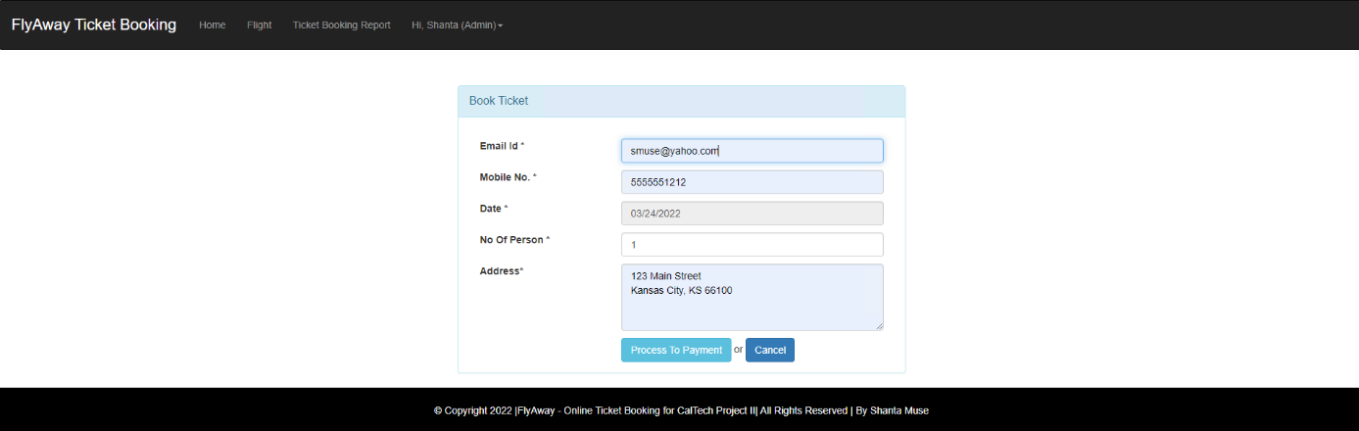

### User Payment Processing

### Payment Confirmation

### Book Ticket List

# Conclusion

## Unique Selling Points

This application can be enhanced by enhancing current features and adding new functionality like additional payment methods, search options, suggestive searches. Mobile application could be added as well.

The selling points of this application is that is a small program that does not take up much space. It has fast performance. Is intuitive and does not require extensive user training. And runs from a web platform.